Cover letter

May 14, 2024

Editorial Department of Journal of Biomedical and Clinical Sciences (JBCS),

Dear Editor of Journal of Biomedical and Clinical Sciences,
I am submitting a case report for consideration of publication in Journal of Biomedical and Clinical Sciences. The manuscript is entitled “Recurrent Clear Cell Meningioma of Cauda Equina in a Middle-Aged Gentleman”.

The work conducted and presented in this manuscript has not been published or submitted for publication in another journal. All authors named in the manuscript have made substantial contribution each to qualify for authorship according to Journal of Biomedical and Clinical Sciences authorship criteria and have approved of the content of the manuscript. We have disclosed all financial support for our work and other potential conflicts of interests.”
Thank you very much for your consideration.

Title page

Recurrent Clear Cell Meningioma of Cauda Equina in a Middle-Aged Gentleman

Lee King Peng ^{1,5}, Nur Asma Sapiai^{2,4,5*}, Zaitun Zakaria^{1,4,5}, Anani Aila Mat Zain^{3,5}, Turgut Tali⁶

¹ Department of Neurosciences, School of Medical Sciences, Universiti Sains Malaysia, 16150 Kota Bharu, Kelantan, Malaysia.
² Department of Radiology, School of Medical Sciences, Universiti Sains Malaysia, 16150 Kota Bharu, Kelantan, Malaysia.
³Department of Pathology, School of Medical Sciences/USM Hospital, Universiti Sains Malaysia, 16150 Kota Bharu, Kelantan, Malaysia.
⁴ Brain and Behaviour Cluster, School of Medical Sciences, Health Campus, Universiti Sains Malaysia, 16150 Kubang Kerian, Kota Bharu, Kelantan, Malaysia
⁵ Hospital Universiti Sains Malaysia, Universiti Sains Malaysia, Health Campus, Jalan Raja Perempuan Zainab 2, 16150 Kota Bharu, Kelantan, Malaysia
⁶Department of Radiology, School of Medicine, Lokman Hekim University, Ankara, Turkey

Corresponding author:
*Dr Nur Asma Sapiai, M.D, M.Med (Rad)
Lecturer/ Radiologist,
Department of Radiology, School of Medical Sciences, Universiti Sains Malaysia, Health Campus,
16150 Kota Bharu, Kelantan, Malaysia.
Tel: +609 7676733; Fax : +609 767 3468; E-mail : drnurasma@usm.my
Orchid ID: 0000-0002-7955-9768
Web of Science Researcher ID : AAF-6624-2019
SCOPUS ID: 57210889524
Google Scholar ID : JGYwvsoAAAAJ

First author
Dr Lee King Peng, M.D
Department of Neurosciences, Hospital Universiti Sains Malaysia, 16150 Kubang Kerian, Kelantan, Malaysia.
kplee5125@gmail.com

Co-author
Dr Zaitun Zakaria, MB BCh BAO (TCD), PhD (RCSI)
Department of Neurosciences, Hospital Universiti Sains Malaysia, 16150 Kubang Kerian, Kelantan, Malaysia.
zakariaz@tcd.ie

Associate Prof Dr Anani Aila Mat Zain, MD, MMed
Lecturer/Specialist,
Department of Pathology,
School of Medical Sciences/USM Hospital,
Universiti Sains Malaysia, Health campus,
16150 Kota Bharu,
Kelantan, Malaysia.
ailakb@usm.my

Prof. Dr. E. Turgut Tali
Department of Radiology, School of Medicine, Lokman Hekim University, Ankara, Turkey
turgut.tali@gmail.com

Statements and Declarations
Ethics approval and consent to participate
Not applicable
Consent for publication
Consent was obtained from the patient for publication of this case report and accompanying images
Competing of interest
No conflict of interest has been disclosed by the authors.
Funds
This study did not receive any special funding.
Availability of data and material
Not applicable
Authors Contributions
All the authors contribute in this case report
Acknowledgements
This manuscript was produced without any financial support from any organization. Many thanks to co-authors for contribution making this manuscript successfully produced.

Abstract
Clear cell meningioma of the cauda equina is an infrequent occurrence. It falls under the Central Nervous System WHO Grade 2, 5th Edition WHO Classification. This type of meningioma is known for its aggressive nature, frequent recurrence, and instances of leptomeningeal metastasis. The radiological findings resemble typical meningioma, but specific indicators of clear cell meningioma include leptomeningeal enhancement, although this feature is not exclusive to it. Therefore, the diagnosis primarily relies on histopathology. Here, we present a case of a 58-year-old local male with a history of laminectomy and excision of clear cell meningioma of the cauda equina.
Keywords: meningioma, clear cell meningioma, cauda equina, laminectomy

Introduction
Spinal meningiomas account for 12% of all meningiomas [1]. However, only 4% of spinal meningiomas are found in the lumbar regions, with a greater prevalence in the thoracic and cervical regions [2]. The clear cell meningioma (CCM) subtype, characterized by round or polygonal cells with clear and glycogen-rich cytoplasm, is a scarce variant among all meningiomas [3]. This particular subtype primarily affects children and young adults [3]. The World Health Organization (WHO) has classified CCM as a Grade 2 tumor of the central nervous system (CNS), and it is known for its aggressive nature, high recurrence rate, and instances of leptomeningeal metastasis [3]. In our case, the patient was diagnosed in middle age with clear cell meningioma, which is a rare type of meningioma and the disease at the atypical location, cauda equina.
Case Report
A 58-year-old local male with no known medical illness initially presented to a nearby referral center with progressive left foot weakness and numbness associated with lower back pain for six months. There was no bowel or bladder involvement, symptoms, or deficits over the right lower limb. A magnetic resonance imaging (MRI) of the lumbosacral spine revealed a well-defined extramedullary elongated lesion over the superior border of L4 till the superior border of S1 measuring approximately 6 cm in craniocaudal, which was seen arising from the cauda equina, favoring for a myxopapillary ependymoma (Figure 1).
The L4-S1 laminectomy and tumor excision were performed. The intraoperative finding was fibrous tissue measuring 5.5cm in length arising from filum terminale extending to the left neural foramen, which was completely excised. Histopathological analysis revealed a pattern-less arrangement of clear cells interspersed with distinct cell borders with prominent perivascular and interstitial thick collagen. The nuclei were small and round, with no mitotic activity. Immunohistochemically, the stain was positive for vimentin, Epithelial membrane antigen (EMA), and Periodic acid-Schiff (PAS), whereas negative for PAS D, CD10, Glial fibrillary acidic protein (GFAP), Cytokeratin (PanCK), and S100. The final impression was CNS WHO Grade 2 CCM (Figure 2).
Post-operatively, his symptoms improved until six months later, when he developed a recurrence of back pain associated with worsening numbness over the left foot and leg. He also started to have numbness of the right foot. On examination, the straight leg raising test was positive bilaterally. The motor powers were normal except for left toe flexion of Medical Research Council (4) grade 4/5. Sensation over the right side was reduced from L5 and below bilaterally.
A follow-up lumbosacral MRI revealed the previous laminectomy of L4-S1. A lobulated intradural lesion at level L5 till S1 measuring approximately 3.7x2.6cm showed a similar imaging appearance as per the initial MRI. The mass was also extended into the left neural foramen (Figure 3). The patient was subjected to a second surgery. Intraoperatively, there was a well-defined brownish nonvascular intradural extramedullary tumor dorsal to the spinal cord, measuring 3.5cm in length, extending into the left neural foramen, for which near total excision was performed. The histology remained unchanged. Postoperatively, the back pain resolved, and he was left with residual numbness over the left L5 dermatome. A follow-up MRI at one month postoperatively revealed a small residual tumor with L5 exiting nerve root impingement. After a multidisciplinary discussion, the patient was planned for radiotherapy for treatment of the residual lesion.

Summary of flowcharts
The patient presents with progressive left foot weakness and numbness for six months

MRI shows cauda equina lesion, raised suspicious of myxopapillary ependymoma

L4-S1 laminectomy and tumour excision were performed after 2 weeks MRI
HPE revealed WHO Grade 2 CCM

Patient discharged with improvement of symptoms

After 6 months post-operation, the patient complaint of recurrent back pain and numbness of left leg and foot

Repeated MRI shows recurrence of lesion
The second surgery of tumor excision was done, and HPE was back as CCM.

Repeated MRI post-second surgery shows a small residual lesion

Discussion
Spinal meningiomas constitute 12% of all meningiomas [3] and approximately 25% of all primary spinal cord tumours, with a male-to-female ratio of 1:4 [4]. The majority of spinal meningiomas are located within the intradural space, while cases with extradural extension are uncommon. Thoracic spinal region is the most common site (80%), followed by the cervical region (16%), whereas the lumbar and cauda equina regions are the least common (4%) [2]. CCM is an exceedingly rare subtype of meningioma characterized by sheets of round or polygonal cells with clear glycogen-rich cytoplasm, along with prominent perivascular and interstitial collagen [3]. CCM predominantly affects children and young adults [3]. It is associated with an aggressive clinical course and occasional metastasis via the cerebrospinal fluid [3,5]. The existing literature on CCM is limited to case reports and small case series, and due to its rarity, the epidemiological and clinical characteristics of CCMs have not been fully elucidated.
The first reported case of CCM was documented by Harkin et al. in 1998 [6]. Electron microscopic analysis of the tumour revealed broad zones with large amianthoid collagen fibres. Initially classified as Grade 1, CCM's classification was later revised to Grade 2 due to its high recurrence rate and aggressive clinical behaviour [5,7]. According to available literature [8,9], CCM is touted as among the rarest subtypes, accounting for approximately 0.2–0.8% of all meningiomas. Limited genetic aberrations have been identified, including mutations in the neurofibromatosis gene (NF-2) [9,10] and SMARCE1 [11-13]. However, the precise aetiology and defining genomic mutations underlying CCM are still unclear.
Zhang et al. conducted separate reviews of reported cases of intracranial CCMs [14] and spinal CCMs [15], revealing a significant female predominance in spinal CCMs. Furthermore, Louis et al. [16] reported that CCMs are more commonly observed in younger patients, including children and young adults [4]. In Zhang's review, it was found that 42.9% of patients with spinal CCMs were younger than 18 years old [17], and the mean age at the time of surgery was 24 years old for spinal CCMs and 32 years old for intracranial CCMs [14,15]. However, it is worth noting that some reports did not show a pronounced preference for the younger population [17].
CCMs are predominantly reported to occur at the cerebellopontine angle, supratentorial and spine, especially in the cauda equina region [3]. Radiologically, CCMs typically exhibit similar characteristics to ordinary meningiomas. They appear isointense on T1-weighted imaging and iso- or hyperintense on T2-weighted imaging, with intense and homogeneous enhancement following the administration of gadolinium [18]. There was also one case report of solid cystic appearance of clear cell meningioma within cerebellopontine angle [19] and another reported case of multifocal intradural extramedullary lesions within thoracic and lumbar spine [20]. Clues suggestive of CCM include leptomeningeal enhancement, even though leptomeningeal enhancement has also been reported in other types of ordinary meningioma [21,22].
Conclusion
CCM is a histologically rare subtype of meningioma that has a higher recurrence rate, compared to typical meningiomas. Recurrence occurs as either local recurrence or as CSF seeding. CCM must hence be followed up carefully because of its aggressive behaviour, even when benign histologic features are reported. As seen in our reported case, it can affect even middle-aged gentleman for which recurrence can occur as early as 6 months postoperatively despite complete excision.

Figures
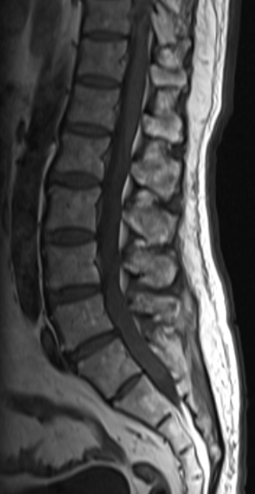 | 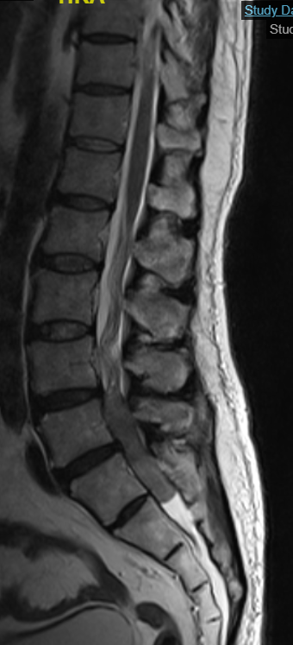 | 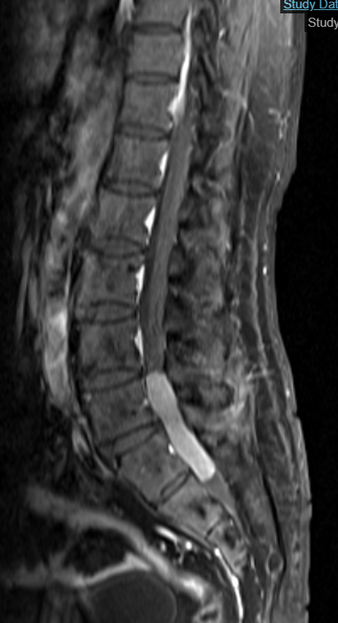
- (B) (C)
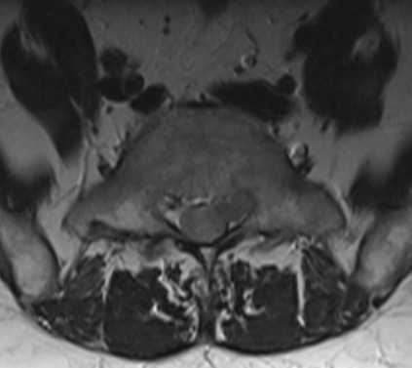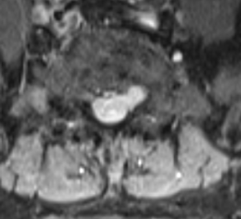
(D) (E)
Figure 1 Magnetic resonance imaging of the lumbosacral (A) Sagittal T1WI, (B) Sagittal T2WI, (C) Sagittal Post-contrast T1, (D) Axial T2 and (E) Axial Post-contrast T1, shows well-defined intradural extramedullary elongated lesion within the spinal canal which is located over the superior border of L4 till the border of S1(arrow). The mass is iso- to hypointense on T1, iso- to hyperintense on T2 and homogenously enhances following the contrast media administration. It has extension into the left neural foramen.

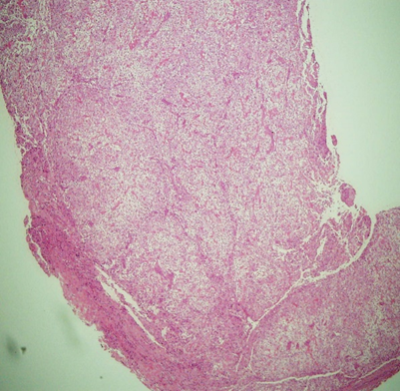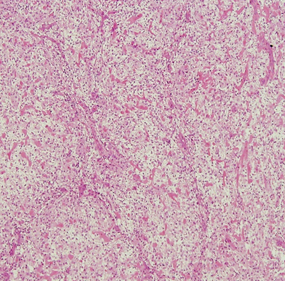
- (B)
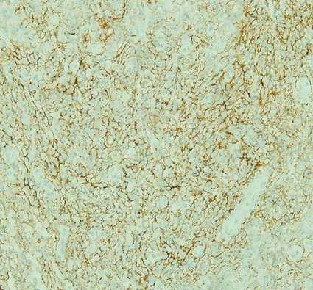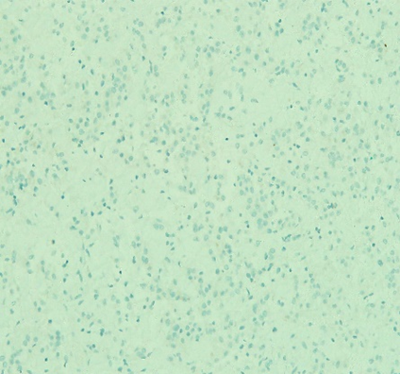
(C) (D)
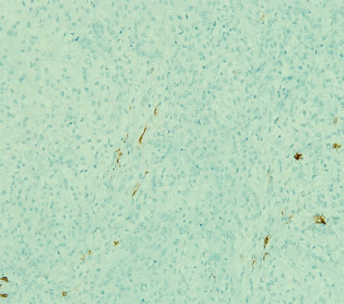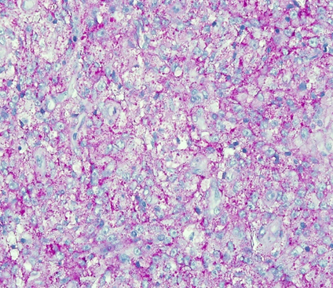
(E) (F)
Figure 2 (A) Haematoxylin and Eosin (H&E) stain (4x magnification), (B) (H&E) (10x magnification), (C) Epithelial membrane antigen (EMA) (X20) positivity, (D) Glial fibrillary acidic protein (GFAP) (X40) negativity, (E) S100 stain (X20) negativity and (F) Periodic acid-Schiff (PAS) stain (X40) positivity revealed a pattern-less arrangement of clear cells interspersed with distinct cell borders with prominent perivascular and interstitial thick collagen, with small, round to oval nucleus with no mitotic activity.
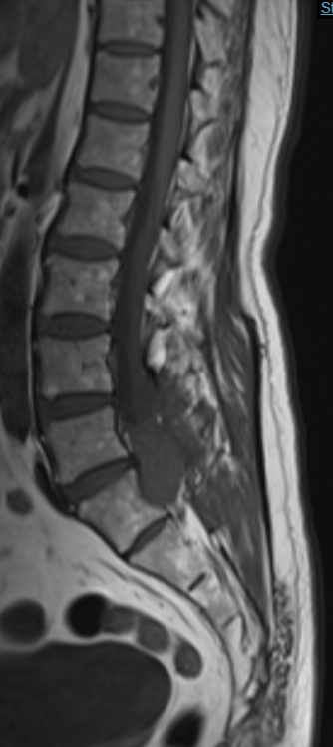 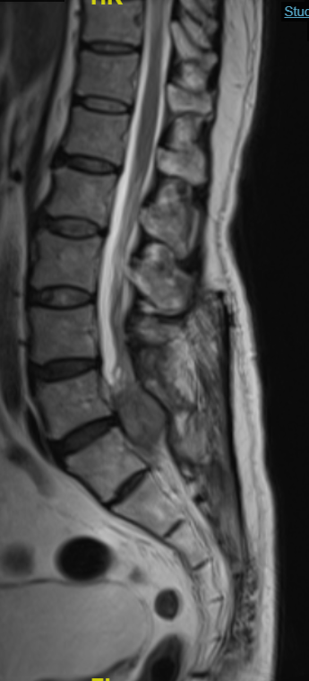 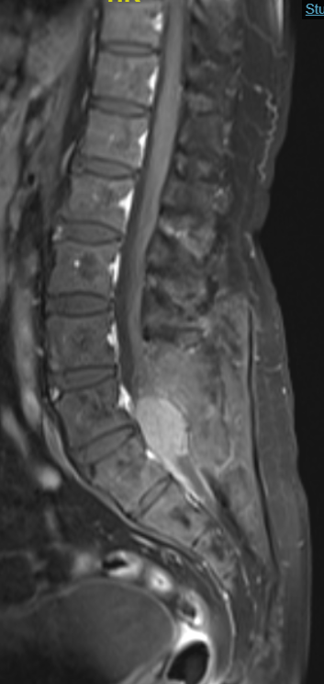
(A) (B) (C)
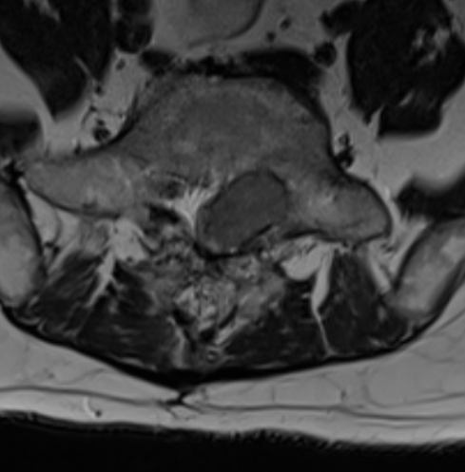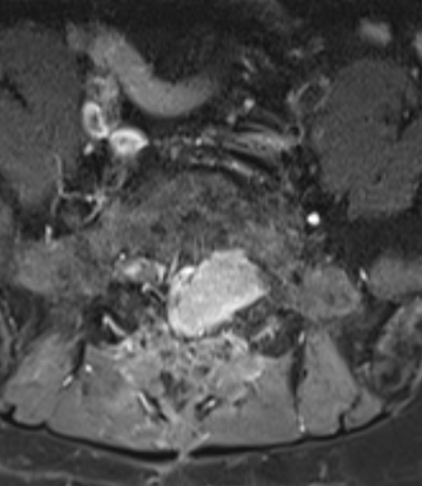
(D) (E)
Figure 3 Magnetic resonance imaging of the lumbosacral (A) Sagittal T1WI, (B) Sagittal T2WI, (C) Sagittal Post-contrast T1WI, (D) Axial T2WI and (E) Axial Post-contrast T1WI show evidence of the previous laminectomy at L4-S1. There is a lobulated intradural lesion within the spinal canal which is located at level L5 till S1(arrow). The mass is isointense on T1, iso- to hyperintense on T2, and homogenously enhances following the contrast media administration. There is also an extension of the mass into the left neural foramen.

References
1. Alsadiq MN, Albarbari ZS, Alshakhs F, Alduayji MA, Al-Umran S, Alenzi A: Spinal clear cell meningioma: Atypical clinical and radiological manifestations. Case Rep Surg 2021:9998399, 2021
2. Bettaswamy G, Ambesh P, Das KK, Sahu R, Srivastava A, Mehrotra A, Jaiswal A, Jaiswal S, Behari S: Extradural spinal meningioma: Revisiting a rare entity. J Craniovertebr Junction Spine 7(1):65-68, 2016
3. Chen HK, Wu YT, Lin YJ, Lin JW: Clear cell meningioma with frequent chordoid features and aggressive behavior: A clinicopathologic study of ten cases at a single institution. J Neurooncol 103(3):551-559, 2011
4. Compston A: Aids to the investigation of peripheral nerve injuries. Medical research council: Nerve injuries research committee. His majesty's stationery office: 1942; pp. 48 (iii) and 74 figures and 7 diagrams; with aids to the examination of the peripheral nervous system. By michael o'brien for the guarantors of brain. Saunders elsevier: 2010; pp. [8] 64 and 94 figures. Brain 133(10):2838-2844, 2010
5. El Khamary SM, Alorainy IA: Case 100: Spinal epidural meningioma. Radiology 241(2):614-617, 2006
6. Gerkes EH, Fock JM, den Dunnen WF, van Belzen MJ, van der Lans CA, Hoving EW, Fakkert IE, Smith MJ, Evans DG, Olderode-Berends MJ: A heritable form of smarce1-related meningiomas with important implications for follow-up and family screening. Neurogenetics 17(2):83-89, 2016
7. Harkin JC, Leonard GL: Abnormal amianthoid collagen fibers in meningioma. Acta Neuropathol 76(6):638-639, 1988
8. Hartmann C, Sieberns J, Gehlhaar C, Simon M, Paulus W, von Deimling A: Nf2 mutations in secretory and other rare variants of meningiomas. Brain Pathol 16(1):15-19, 2006
9. Jain D, Sharma MC, Sarkar C, Suri V, Garg A, Singh M, Sharma BS, Mahapatra AK: Clear cell meningioma, an uncommon variant of meningioma: A clinicopathologic study of nine cases. J Neurooncol 81(3):315-321, 2007
10. Kamiya K, Inagawa T, Nagasako R: Malignant intraventricular meningioma with spinal metastasis through the cerebrospinal fluid. Surg Neurol 32(3):213-218, 1989
11. Li MH, Holtås S, Larsson EM: Mr imaging of intradural extramedullary tumors. Acta Radiol 33(3):207-212, 1992
12. Louis DN, Perry A, Reifenberger G, von Deimling A, Figarella-Branger D, Cavenee WK, Ohgaki H, Wiestler OD, Kleihues P, Ellison DW: The 2016 world health organization classification of tumors of the central nervous system: A summary. Acta Neuropathol 131(6):803-820, 2016
13. Louis DN, Perry A, Wesseling P, Brat DJ, Cree IA, Figarella-Branger D, Hawkins C, Ng HK, Pfister SM, Reifenberger G, Soffietti R, von Deimling A, Ellison DW: The 2021 who classification of tumors of the central nervous system: A summary. Neuro Oncol 23(8):1231-1251, 2021
14. Matsui H, Kanamori M, Abe Y, Sakai T, Wakaki K: Multifocal clear cell meningioma in the spine: A case report. Neurosurg Rev 21(2-3):171-173, 1998
15. Miller AA, Ramsden F: Malignant meningioma with extracranial metastases and seeding of the subarachnoid space and the ventricles. Pathol Eur 7(2):167-175, 1972
16. Smith MJ, Ahn S, Lee JI, Bulman M, Plessis DD, Suh YL: Smarce1 mutation screening in classification of clear cell meningiomas. Histopathology 70(5):814-820, 2017
17. Tao X, Dong J, Hou Z, Hao S, Zhang J, Wu Z, Liu B: Clinical features, treatment, and prognostic factors of 56 intracranial and intraspinal clear cell meningiomas. World Neurosurg 111:e880-e887, 2018
18. Tauziede-Espariat A, Parfait B, Besnard A, Lacombe J, Pallud J, Tazi S, Puget S, Lot G, Terris B, Cohen J, Vidaud M, Figarella-Branger D, Monnien F, Polivka M, Adle-Biassette H, Varlet P: Loss of smarce1 expression is a specific diagnostic marker of clear cell meningioma: A comprehensive immunophenotypical and molecular analysis. Brain Pathol 28(4):466-474, 2018
19. Yu KB, Lim MK, Kim HJ, Suh CH, Park HC, Kim EY, Han HS: Clear-cell meningioma: Ct and mr imaging findings in two cases involving the spinal canal and cerebellopontine angle. Korean J Radiol 3(2):125-129, 2002
20. Zhang GJ, Zhang YS, Zhang GB, Yan XJ, Li CB, Zhang LW, Li D, Wu Z, Zhang JT: Prognostic factors, survival, and treatment for intracranial world health organization grade ii chordoid meningiomas and clear-cell meningiomas. World Neurosurg 117:e57-e66, 2018
21. Zhang H, Ma L, Shu C, Dong LQ, Ma YQ, Zhou Y: Spinal clear cell meningiomas: Clinical features and factors predicting recurrence. World Neurosurg 134:e1062-e1076, 2020
22. Zhang H, Ma L, Wang YB, Shu C, Kuang W, Huang YA, Dong LQ, Cheng GG: Intracranial clear cell meningiomas: Study on clinical features and predictors of recurrence. World Neurosurg 97:693-700.e611, 2017

