FIGURES

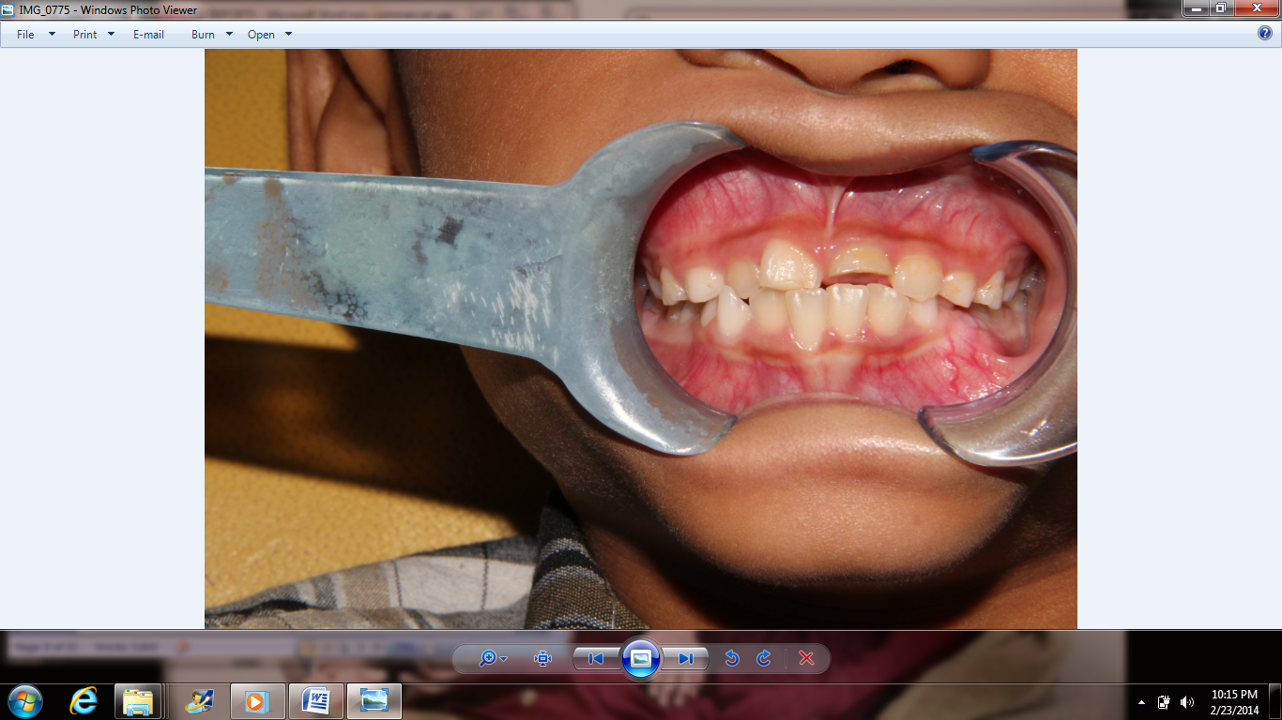
Figure 1 : Anterior view shows complicated crown fracture with pulp expose of UL1

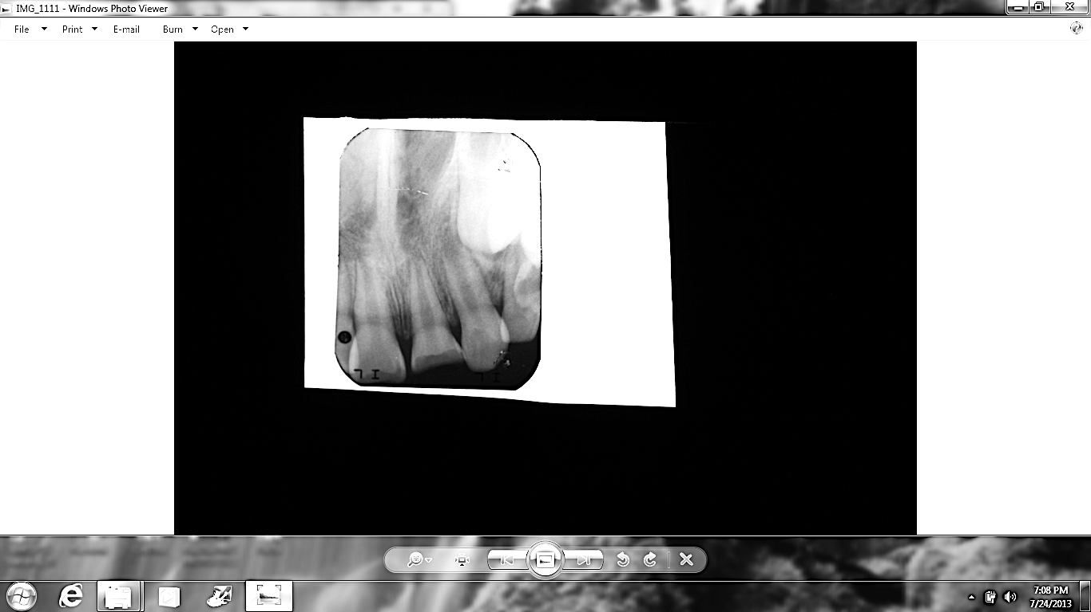
Figure 2: Intraoral periapical radiograph shows open apices of UL1 and UR1, and periapical radiolucency

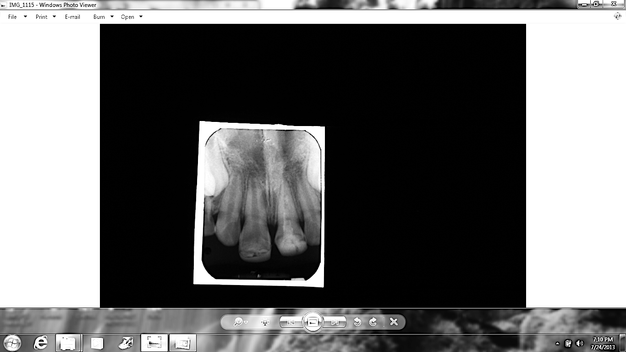
Figure 3: Apical closure of UL1 with some evident of radiopacity inside the canal (MTA plug and irregular dentin deposition) at 12 months review. Noted that no radiolucency at surrounding apical region.

