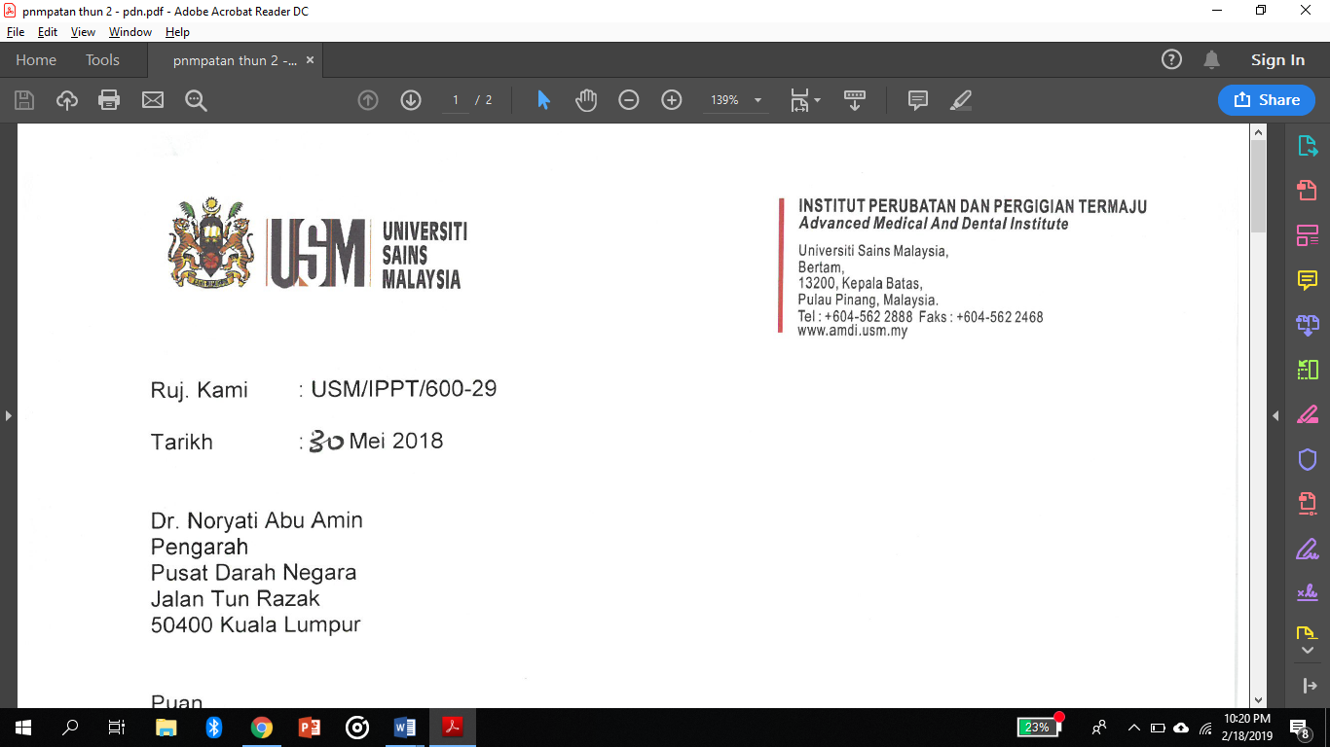

Date: 19 November 2020
Dr Soon Eu Chong
Section Editor,
Journal of Biomedical and Clinical Sciences
Universiti Sains Malaysia
Dear Dr,
RE: Amendment of Case Report
Study Title : A normal absolute neutrophils count in bacterial infection: A precaution step needed.
Author’s Name : Mohd Redzuan Bin Abdullah, Hafizuddin Mohamed Fauzi
No. | Comments/suggestion by reviewer B and C | Remarks by author | Refer Page
 | Abstract - Is it  possible to highlight the total white count & neutrophil absolute count? | Amended.  “Despite underlying infection, total white blood cell count (TWBC) and absolute neutrophil count remained normal”. The value is not mention here as this is an abstract. | 1
 | Keyword - In this case was the total WBC low? | Amended.  - “pseudoleukopenia” was removed.It was a mistake. The total WBC is not low. | 1
 | Figure - Please highlight (a) at the tail area &(b) at the body area on the smear | Amended for all figure | 3,4,5
 | Discussion- How about her other RBC parameters e.g. MCV, MCH & MCHC? Are these parameters  support IDA? | Amended – “With regards to her anaemia, red blood cell morphologically was normochromic (MCH 30 pg) normocytic (MCV 86 fL) with normal MCHC of 32.2 g/dL. However, the patient’s iron was found to be low which was suggestive of iron deficiency despite high serum ferritin due to its nature as acute-phase protein. The red blood cells MCV and MCH value still within normal, perhaps due to the early phase of iron deficient. She was treated empirically with haematinic. | 8
 | Comment- interesting case report but must emphasize more on clinical value, why do  we need to detect neutrophil agglutination early as clinical management is  still the same? | Amended (Discussion)- “Accurate WBC count is important for monitoring response toward antibiotic in septicaemic patient. WBC count also was part of risk stratification criteria and monitoring response toward chemotherapy in heamatological malignancy. In certain group of patient such as neonate, increment in WBC may the only abnormality detected with minimal symptom presentation” | 7
 | Comment- need clear time line, when was the first admission, when was the first fbp taken, the first antibiotic given? This is important for reader to interpret the clinical situation with wbc count | Amendment (Case report) – admitted on 31st December 2016 , 1st FBP taken on admission, repeated FBP taken on Day 7 of admission, antibiotic was started on admission.  Note: The date was not put earlier as it is in 2016 case.From my readings, sometime the author dont put date but just put how many days.But if the reviewer agree that the year 2016 is not important to be put, it can be rephrase as late in Disember. | 2,3,4,5,6
 | Comment- suggest to reduce number of images, and please provide clear images | Amendment – Figure 1(b), 2(b), 3(a) and 3(b) were removed.  Figure 1(a), 1(c), 2(a) and 3(c) were kept and enlarged | 3,4,5
 | Table 1 is not self-explanatory and not appropriate in discussion  section, please include as result. | Amendment- table 1 was included in result section and explained- “Repeated WBC count and neutrophil count from a sample using EDTA, sodium citrate, and heparinised tube were within normal range. Manipulation of temperature also showed similar findings” | 5,6
 | conclusion is weak as not supported by result | Amended – “In conclusion, when the total WBC and absolute neutrophil count does not tally with the patient's clinical picture, differential count based on a blood smear is the best method to ascertain the true count. Therefore, clinicians need to be aware of the existence of this phenomenon, especially in a group of patients diagnosed with hematological malignancy, septicaemic patient or any group of patient that accurate WBC count is critical in guiding the management.  ”. | 8
 | all references are more than 10 years ago. please include recent  reference. | Explaination – literature regarding neutrophil agglutination is limited. The latest that i could find was published in year 2009. | -

Your attention and approval of this protocol is highly appreciated.
Yours sincerely,
............................................................
Mohd Redzuan Bin Abdullah
First author
Dr Hafizuddin Mohamed Fauzi
Corresponding author

