A normal absolute neutrophils count in bacterial infection: A precaution step needed.
Abstract
The rare condition of neutrophils agglutination in-vitro may give inaccurate neutrophils count. We reported a case of a 71-year-old female admitted with a diagnosis of extended-spectrum beta-lactamase (ESBL) Escherichia Coli (E.coli) septicaemia secondary to the left lower limb cellulitis. Despite underlying infection, total white blood cell count (TWBC) and absolute neutrophil count remained normal. An accidental finding of full blood picture (FBP) using K2 ethylenediaminetetraacetic acid (EDTA) tube presented numerous neutrophils agglutination. Further tests were carried out using citrated and heparinised tubes and tested at room temperature, 4 ͦC, and 37 ͦC. The findings showed a significant reduction in neutrophils agglutination in both citrated and heparinised tubes, including when tested at room temperature (RT) and 4 ͦC. Surprisingly, at 37 ͦC, no neutrophil agglutination was observed. This indicates that temperature-dependent anti-neutrophil IgM antibody may be found in the patient's serum that reacted with the EDTA anticoagulant. In conclusion, white blood cells (WBC) agglutination has been associated with malignancy, sepsis, liver disease, and autoimmune disease. Thus, a baseline FBP is recommended for investigation, especially in these categories, to optimise the patient's clinical management.
Keywords: neutrophil count, neutrophil agglutination, full blood picture

Introduction
White blood cells (WBC) agglutination in-vitro is a rare condition. It may lead to pseudoleukopenia or inaccurate normal count results in an expected leukocytosis patient. Thus, it may affect in clinical interpretation of the laboratory result. Most reports of WBC agglutinations are based on a case report basis (1,2,3).
Here another rare case of WBC agglutinations has been identified, which specifically originated from neutrophils, accidentally detected by full blood picture (FBP). The following provides the details of the case.
Case report
A 71-year-old Chinese female was admitted to the medical ward on 31st December 2016 for intermittent fever with chill and rigor for two weeks before presentation. The symptoms were associated with bilateral lower limb weakness and swelling. She was bed-bound for the past three weeks before admission. There was no history of trauma or fall. She has chronic illnesses, namely diabetes mellitus, chronic kidney disease (CKD), and right knee osteoarthritis but defaulted follow up. She had a history of hysterectomy in a private hospital for cervical carcinoma in 2013. Currently, she is not on any regular medication. She is single, nulliparous, unemployed, and stays with a sister.
On examination, she was alert, orientated, and pink at room air. Vital signs were stable. Bilateral lower limbs were swelling associated with erythematous skin and superficial ulcer on her left shin. Neurological examination revealed reduced muscle tone and power of bilateral lower limbs. Other systemic examinations were unremarkable.
An initial full blood count showed anaemia (Hb8.4g/dl) with a normal total WBC of 7.8x10³/μL (the absolute neutrophil count was 6.4x10³/μL). Renal function test showed deranged results with hypokalaemia (2.9 mmol/L), uraemia (17.1 mmol/L), and high creatinine level (193 mmol/L) which correspond to her CKD. Blood culture and sensitivity were revealed to be positive for extended-spectrum beta-lactamase (ESBL) Escherichia Coli with antibiotic sensitivity toward amikacin, imipenem, meropenem, gentamicin, and ertapenem. Otherwise, other investigations were normal.
Serum ferritin, serum iron, and FBP were ordered as part of the investigation of anaemia on the day of admission. Serum ferritin was high (787 ug/L), but serum iron was low (2.9 umol/L). A blood sample was collected using a K2 ethylenediaminetetraacetic acid (EDTA) tube, and Wright's stain was used for slide preparation. The result showed the presence of significant neutrophils agglutination with other morphological features suggestive of infection (Figure 1).
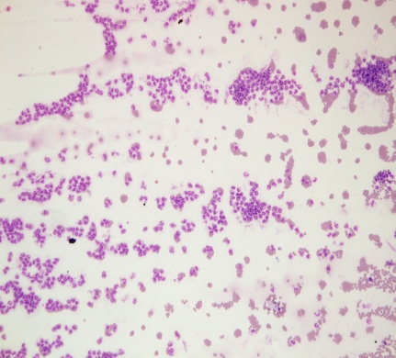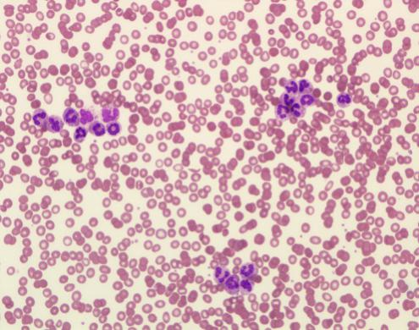
(b)a
(a)a
Fig. 1: Initial FBP showed numerous neutrophils agglutination in EDTA tube (200x magnification for (a) at the tail area and 400x magnification for (b) at body area of smear
Further tests were carried out to investigate the cause of neutrophil agglutinations. FBP was repeated on Day 7 of admission using a citrated tube (Figure 2) and heparinised tube. FBP was also repeated using a blood sample which was incubated at room temperature (RT), 4 ͦC, and 37 ͦC (Figure 3) for 5 minutes. Findings showed significantly reduced neutrophil agglutinations in both citrated and heparinised tubes, including when tested at RT and 4 ͦC. Surprisingly, neutrophil agglutination was disappeared when using a blood sample incubated at 37 ͦC.

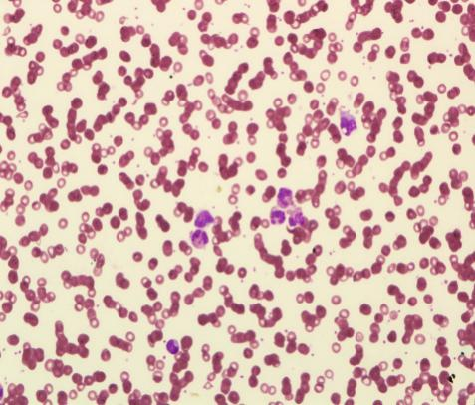
Fig. 2: Mild neutrophil agglutination using a citrated tube (400x magnification) at body area of the smear
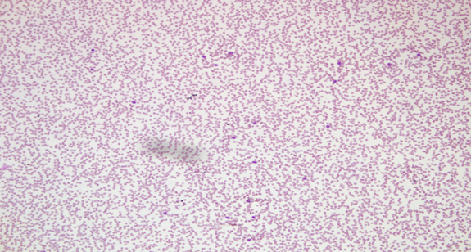
Fig. 3: Absence of neutrophil agglutination at 37 ͦC (200x magnification) at body area of the smear
The patient's total WBC and neutrophils count remain normal although neutrophilia was expected in bacterial infection. Repeated WBC count and neutrophil count from a sample using EDTA, sodium citrate, and heparinised tube were within the normal range. Manipulation of temperature also showed similar findings (Table 1).

Parameter | *EDTA | *Sodium Citrate | *Heparinised | **Room temperature | **4 ͦC | **37 ͦC | Normal Range
WBC count  (x10³/μL) | 7.7 | 6.9 | 5.8 | 6.3 | 6.1 | 6.0 | 3.4-10.0
Neutrophil  (x10³/μL) | 6.1 | 5.5 | 4.2 | 4.3 | 4.5 | 4.4 | 1.55-6.07

Table 1: WBC count and neutrophil count using different tube and at different temperature.
*These tests were done at a room temperature
**These tests were done using EDTA tube at three different temperatures

Serum immunoglobulin subclass IgM and IgG were 1.33 g/l (0.45-1.45) and 14.8 g/dl (5.5-15.0) respectively. Direct and indirect antihuman globulin test (AHG) was negative. The patient was observed in the ward. Only one-episode spiking of temperature (38.5 ͦC) during admission was noted. Otherwise, vital signs were stable throughout the admission. She was started with intravenous (IV) Unasyn 750mg TDS on admission but later at Day 5 of admission changed to IV Imipenem 500mg TDS as guided by blood culture and sensitivity result. Mist potassium chloride was given because of hypokalemia and haematinic for the iron deficiency anaemia. She was discharged on 18th January 2017 after completed IV antibiotics for two weeks and clinically recovered.

Discussion
WBC agglutination has been associated with malignancy, sepsis, liver disease and autoimmune disease (2). Accurate WBC count is important for monitoring response toward antibiotic in a septicaemic patient. WBC count also was part of risk stratification criteria and monitoring response toward chemotherapy in haematological malignancy. In a particular group of a patient such as a neonate, increment in WBC may the only abnormality detected with minimal symptom presentation. In our case, the patient was diagnosed with ESBL E.coli septicemia, evidenced by blood culture. The neutrophils agglutinations might have gone undetected if FBP was not sent. During admission, the patient's total WBC and neutrophils count remain normal although neutrophilia was expected in bacterial infection (Table 1). There are three possible explanations; one would be due to the presence of neutrophils agglutination itself where the machine cannot give an accurate count. The other might be due to low immune response since the patient is in her advanced age, and the third cause could be due to the complete response to the antibiotic given.
In the previous literature review, WBC agglutination mechanism was postulated due to the use of K2-EDTA anticoagulant or temperature-dependent (1,2,4,5). This is reflected in our case where significant neutrophils agglutination that was seen in the EDTA tube has reduced its intensity when used in citrated and heparinised tubes. The nature of its temperature-dependent was well observed where neutrophils agglutination that was initially seen at room temperature and 4 ͦC had resolved entirely at 37 ͦC (using EDTA tube). This indicates that temperature-dependent anti-neutrophil IgM antibody (which is known to have optimum activity at cold temperature) may present in the patient's serum that reacts with EDTA anticoagulant. However, the patient's serum immunoglobulin IgM was normal, although it was on an upper border normal range value. This is probably because the immunoglobulin has reduced to a normal range as the body responded to the antibiotic given to the patient earlier. We also have excluded the presence of other atypical antibodies that might be causing similar findings. This is proven by negative direct and indirect AHG test.
With regards to her anaemia, red blood cell morphologically was normochromic (MCH 30 pg) normocytic (MCV 86 fL) with normal MCHC of 32.2 g/dL. However, the patient's iron was found low, which was suggestive of iron deficiency despite high serum ferritin due to its nature as an acute-phase protein. The red blood cells MCV and MCH values are still within normal, perhaps due to the early phase of iron deficient. She was treated empirically with haematinic.
WBC agglutination is usually a transient phenomenon. It disappears when the underlying cause resolved. However, few cases reported persistent WBC agglutination up to 5 years duration (5). Further plan to monitor a full blood picture in this patient was not done as she defaulted follow-up.
In conclusion, when the total WBC and absolute neutrophil count does not tally with the patient's clinical picture, differential count based on a blood smear is the best method to ascertain the true count. Therefore, clinicians need to be aware of the existence of this phenomenon, especially in a group of patients diagnosed with haematological malignancy, septicaemic patient or any group of a patient that accurate WBC count is critical in guiding the management.

Acknowledgement
Acknowledgement is made to all the haematology laboratory personnel at the Advanced Diagnostic Laboratory, Advanced Medical and Dental Institute Universiti Sains Malaysia who had helped us in running the test using the haematology analyser XE Sysmex. The work is supported financially under Universiti Sains Malaysia Research Grant (Short-Term:304/CIPPT/6315198).
References
(1) Glasser L. Pseudo-neutropenia secondary to leukoagglutination. Am J Hematol. 2005;80:147.
(2) Dagan Yang, MS, Xichao Guo, BS, Yu Chen, MD, Genyun Xu, BS. Leukocyte Aggregation In Vitro as a Cause of Pseudoleukopenia. Lab medicine. Feb 2008; 39:2.
(3) Preethi Paul, Naveen Kakkar. Neutrophil Aggregates in a Young Female With Sepsis. Lab medicine. March 2009; 40:3.
(4) Urbach J, Rogowski O, Branski D. Leukocyte aggregation-related pseudoleukopenia in pediatrics: A sporadic event or a systematic error? PediatrInfect Dis J. 2005;24:717–720.
(5) Lesesve JF, Haristoy X, Lecompte T. EDTA-dependent leukoagglutination. Clin Lab Haematol. 2002;24:67–69.

