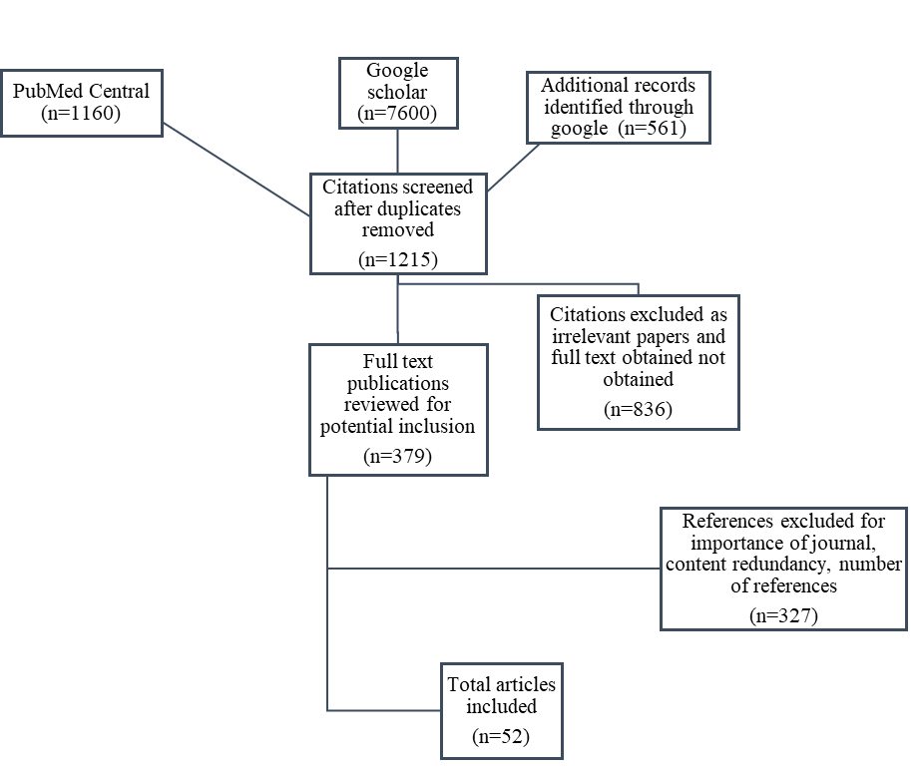
Figure 1: Flow chart summarizing the literature selection process

