Supplementary Data

A: Raw data of Mortality rate
24 hours post fertilization (hpf)
Conc. (mg/L) | Mortality Percentage (%)
53.125 | 6.67
106.25 | 11.67
212.5 | 13.33
425 | 20.00
850 | 15.00
1700 | 28.33
3,4-DCA | 100.00
Negative control | 0.00
Solvent control (0.1% DMSO) | 0.00

48 hours post fertilization (hpf)
Conc. (mg/L) | Mortality Percentage (%)
53.125 | 6.67
106.25 | 11.67
212.5 | 13.33
425 | 20.00
850 | 18.33
1700 | 30.00
3,4-DCA | 100.00
Negative control | 0.00
Solvent control (0.1% DMSO) | 0.00

72 hours post fertilization (hpf)
Conc. (mg/L) | Mortality Percentage (%)
53.125 | 6.67
106.25 | 11.67
212.5 | 13.33
425 | 21.67
850 | 31.67
1700 | 90.00
3,4-DCA | 100.00
Negative control | 0.00
Solvent control (0.1% DMSO) | 0.00

96 hours post fertilization (hpf)
Conc. (mg/L) | Mortality Percentage (%)
53.125 | 6.67
106.25 | 11.67
212.5 | 16.67
425 | 21.67
850 | 33.33
1700 | 100.00
3,4-DCA | 100.00
Negative control | 0.00
Solvent control (0.1% DMSO) | 0.00

B: Raw data on size of eyes at 72 and 96 hpf
Compound  (mg/L) | Eye size (µm²)  N | Eye size (µm²)  Mean | Eye size (µm²)  Standard Error
1700 | 100 | 123.828000 | 4.141361
850 | 100 | 198.950288 | 3.564072
425 | 100 | 222.880495 | 3.033250
212.5 | 100 | 243.473056 | 4.683906
106.25 | 100 | 233.693632 | 4.798698
53.125 | 100 | 231.099599 | 3.104060
control | 100 | 247.565250 | 3.233571

C: Raw data on pericardia area at 72 and 96 hpf
Compound  (mg/L) | Pericardia area (µm²)  N | Pericardia area (µm²)  Mean | Pericardia area (µm²)  Standard Error
1700 | 100 | 276.352343 | 9.829357
850 | 100 | 170.985356 | 6.954869
425 | 100 | 130.817438 | 2.588176
212.5 | 100 | 110.672050 | 2.906610
106.25 | 100 | 102.106621 | 2.518378
53.125 | 100 | 87.393940 | 2.359938
control | 100 | 82.702171 | 2.272339

D: Raw data on behavioral activity 120 hpf
Independent Variable  Treatment (g/mL) | Distance moved  Total (N) | Distance moved  Mean (mm) | Distance moved  Standard Error (mm)
212.5 | 61 | 14727.1 | 949.825
425 | 55 | 12534.1 | 835.022
850 | 56 | 9826.64 | 587.794
control | 58 | 15507.7 | 791.317

E: Raw data on the alternate dark light condition of larvae at 120 hpf
Independent Variable  Treatment  (mg/L) | Time (min) | Distance moved  N | Distance moved  Mean (mm) | Distance moved  Standard Error (mm)
212.5 | Start-0:01:00 | 61 | 925.895 | 85.2218
212.5 | 0:01:00-0:02:00 | 61 | 951.122 | 87.586
212.5 | 0:02:00-0:03:00 | 61 | 999.276 | 91.3688
212.5 | 0:03:00-0:04:00 | 61 | 981.076 | 76.3868
212.5 | 0:04:00-0:05:00 | 61 | 984.912 | 77.075
212.5 | 0:05:00-0:06:00 | 61 | 889.558 | 56.4806
212.5 | 0:06:00-0:07:00 | 61 | 844.118 | 50.0791
212.5 | 0:07:00-0:08:00 | 61 | 833.391 | 56.1423
212.5 | 0:08:00-0:09:00 | 61 | 826.778 | 49.2917
212.5 | 0:09:00-0:10:00 | 61 | 846.194 | 50.5485
212.5 | 0:10:00-0:11:00 | 61 | 899.029 | 49.2744
212.5 | 0:11:00-0:12:00 | 61 | 1099.51 | 66.8896
212.5 | 0:12:00-0:13:00 | 61 | 1456.45 | 94.7215
212.5 | 0:13:00-0:14:00 | 61 | 1582.22 | 103.985
212.5 | 0:14:00-0:15:00 | 61 | 1622.61 | 117.256
425 | Start-0:01:00 | 55 | 633.058 | 73.2715
425 | 0:01:00-0:02:00 | 55 | 729.369 | 76.3626
425 | 0:02:00-0:03:00 | 55 | 782.278 | 76.2348
425 | 0:03:00-0:04:00 | 55 | 828.303 | 77.9538
425 | 0:04:00-0:05:00 | 55 | 820.549 | 70.632
425 | 0:05:00-0:06:00 | 55 | 813.027 | 58.405
425 | 0:06:00-0:07:00 | 55 | 827.309 | 63.6414
425 | 0:07:00-0:08:00 | 55 | 820.622 | 58.3987
425 | 0:08:00-0:09:00 | 55 | 802.647 | 52.1392
425 | 0:09:00-0:10:00 | 55 | 825.361 | 46.6683
425 | 0:10:00-0:11:00 | 55 | 891.065 | 52.6711
425 | 0:11:00-0:12:00 | 55 | 912.732 | 57.8074
425 | 0:12:00-0:13:00 | 55 | 1116.22 | 76.8413
425 | 0:13:00-0:14:00 | 55 | 1131.48 | 79.768
425 | 0:14:00-0:15:00 | 55 | 1198.62 | 86.5765
850 | Start-0:01:00 | 56 | 311.747 | 31.8753
850 | 0:01:00-0:02:00 | 56 | 426.064 | 40.6241
850 | 0:02:00-0:03:00 | 56 | 461.677 | 50.8501
850 | 0:03:00-0:04:00 | 56 | 533.362 | 56.5992
850 | 0:04:00-0:05:00 | 56 | 547.516 | 52.7158
850 | 0:05:00-0:06:00 | 56 | 636.616 | 47.6156
850 | 0:06:00-0:07:00 | 56 | 708.337 | 48.0673
850 | 0:07:00-0:08:00 | 56 | 760.03 | 49.5611
850 | 0:08:00-0:09:00 | 56 | 753.129 | 45.2726
850 | 0:09:00-0:10:00 | 56 | 772.135 | 44.4263
850 | 0:10:00-0:11:00 | 56 | 765.453 | 38.0344
850 | 0:11:00-0:12:00 | 56 | 817.705 | 49.1269
850 | 0:12:00-0:13:00 | 56 | 984.741 | 66.9242
850 | 0:13:00-0:14:00 | 56 | 1041.14 | 76.6887
850 | 0:14:00-0:15:00 | 56 | 930.044 | 50.693
control | Start-0:01:00 | 58 | 1019.07 | 77.4139
control | 0:01:00-0:02:00 | 58 | 937.463 | 65.4769
control | 0:02:00-0:03:00 | 58 | 1050.03 | 67.1362
control | 0:03:00-0:04:00 | 58 | 1089.6 | 73.385
control | 0:04:00-0:05:00 | 58 | 1095.89 | 75.0413
control | 0:05:00-0:06:00 | 58 | 1072.09 | 58.5875
control | 0:06:00-0:07:00 | 58 | 1010.44 | 56.8661
control | 0:07:00-0:08:00 | 58 | 945.044 | 43.9783
control | 0:08:00-0:09:00 | 58 | 933.193 | 51.9733
control | 0:09:00-0:10:00 | 58 | 936.843 | 55.7884
control | 0:10:00-0:11:00 | 58 | 953.401 | 51.9163
control | 0:11:00-0:12:00 | 58 | 1089.3 | 69.0619
control | 0:12:00-0:13:00 | 58 | 1451.38 | 97.7361
control | 0:13:00-0:14:00 | 58 | 1469.51 | 105.63
control | 0:14:00-0:15:00 | 58 | 1492.98 | 103.451

F: Raw data on larvae activity against alternate time at 120 hpf
Time (min) | Treatment | Distance moved  Mean (mm) | Distance moved  Standard Error (mm)
00.00-05.00  (Dark condition) | 212.5 | 968.4562 | 83.52768
00.00-05.00  (Dark condition) | 425 | 758.7114 | 74.89094
00.00-05.00  (Dark condition) | 850 | 456.0732 | 46.5329
00.00-05.00  (Dark condition) | control | 1038.4106 | 71.69066
05.00-10.00  (Light condition) | 212.5 | 848.0078 | 52.50844
05.00-10.00  (Light condition) | 425 | 817.7932 | 55.85052
05.00-10.00  (Light condition) | 850 | 726.0494 | 46.98858
05.00-10.00  (Light condition) | control | 979.522 | 53.43872
10.00-15.00  (Dark condition) | 212.5 | 1331.9638 | 86.4253
10.00-15.00  (Dark condition) | 425 | 1050.0234 | 70.73286
10.00-15.00  (Dark condition) | 850 | 907.8166 | 56.29344
10.00-15.00  (Dark condition) | control | 1291.3142 | 85.55906

G: Comparison between normal and abnormal development of zebrafish embryo-larvae
No. | Abnormal Development | Normal Development
1. | 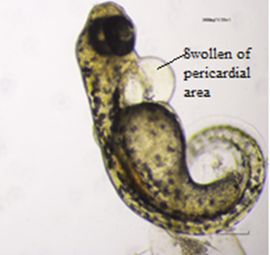  Development of pericardial edema around pericardia area in 1700mg/L at 72 hpf. Pericardial edema was indicated by swollen of pericardia area. | 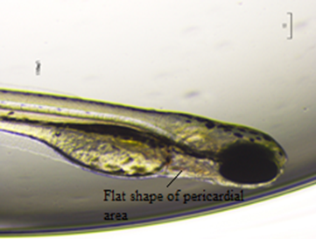  Normal development of pericardial area of negative control group at 72 hpf. Pericardial area was flat and no swollen detected.
2. | 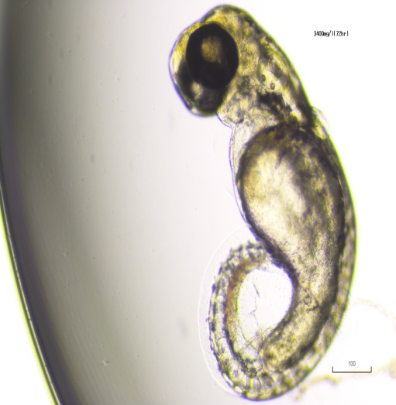  Bending shaped of the larvae due to toxicity of estradiol at 72 hpf | 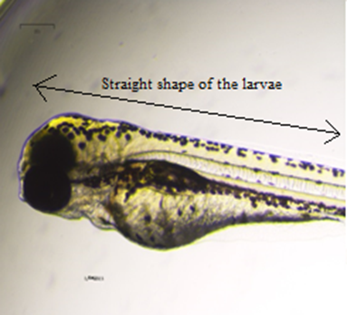  Straight shape of the larvae in negative control group at 72 hpf.

No. | Abnormal Development | Normal Development
3. | 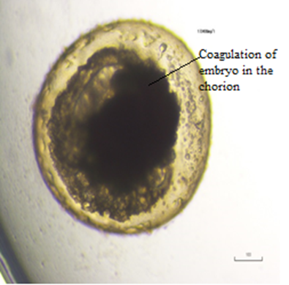  Coagulation of embryo at 1700mg/L of estradiol at 24 hpf | 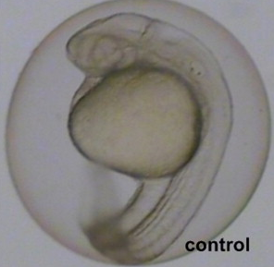  Normal development of embryo in negative control group at 24 hpf
4. | 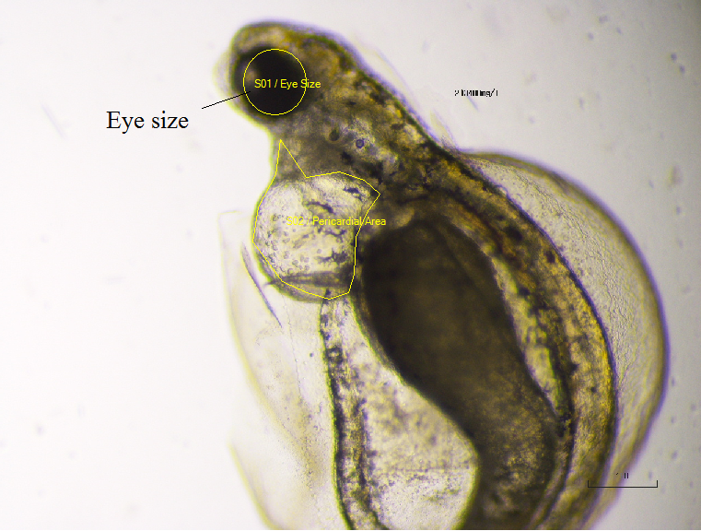  Small eyes size development of the larvae due to toxicity of estradiol at 72 hpf. | 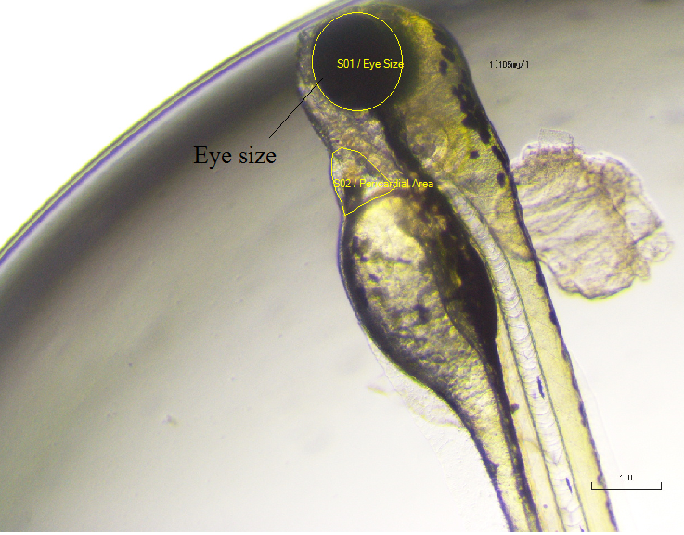  Normal eyes size development of the larvae in control group at 72 hpf.

H: Behavioral activity using high end infrared image analysis for behavioral activities
