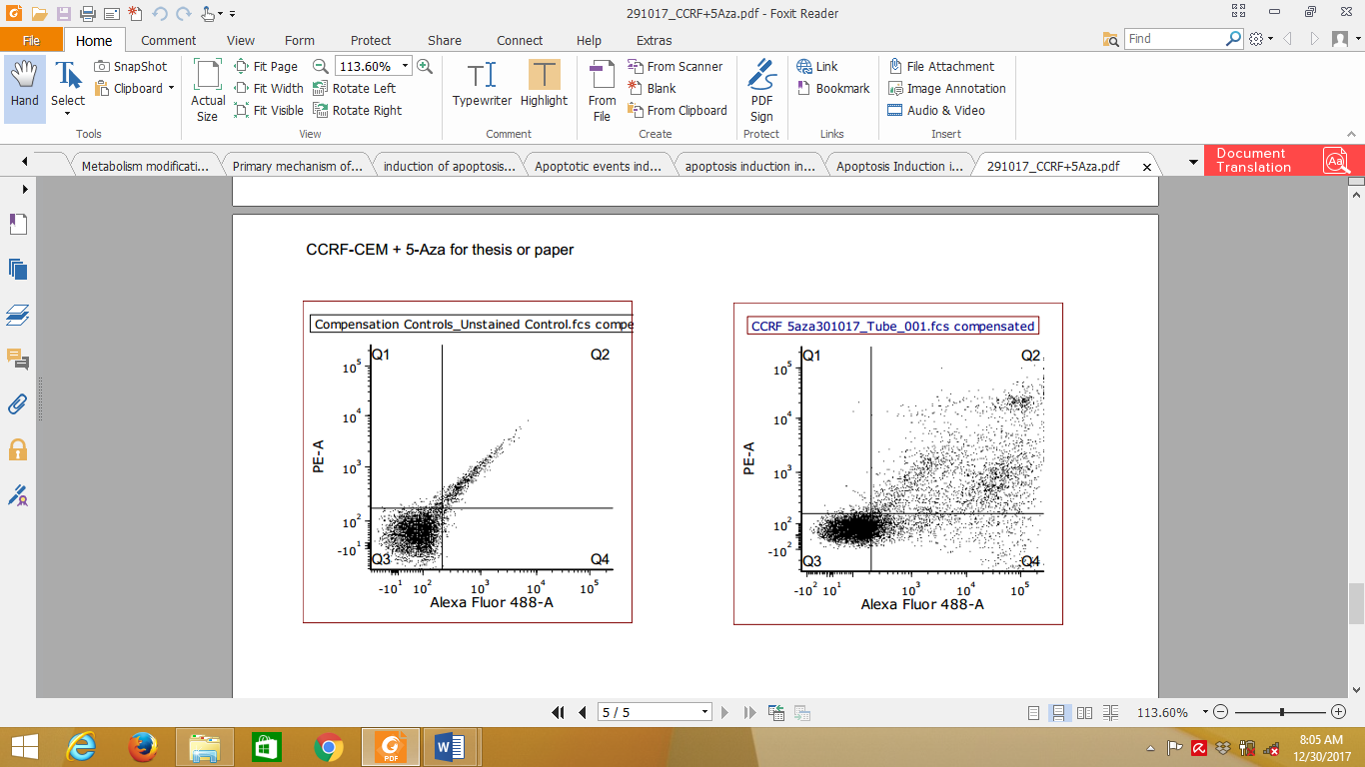
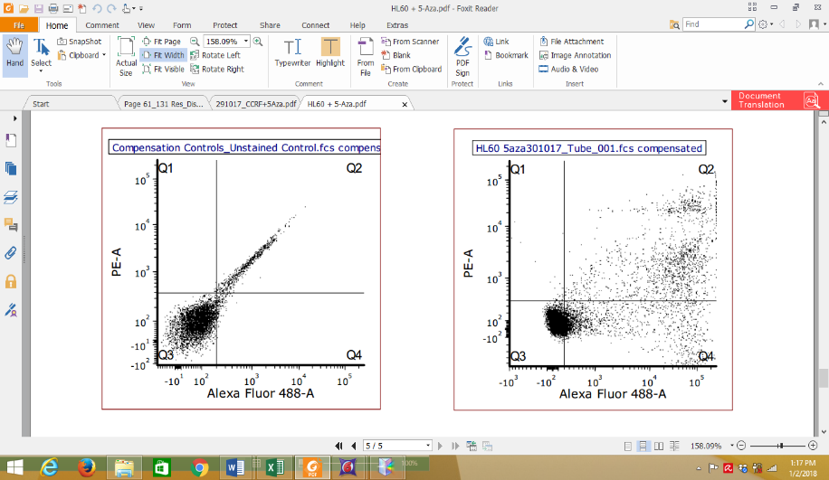
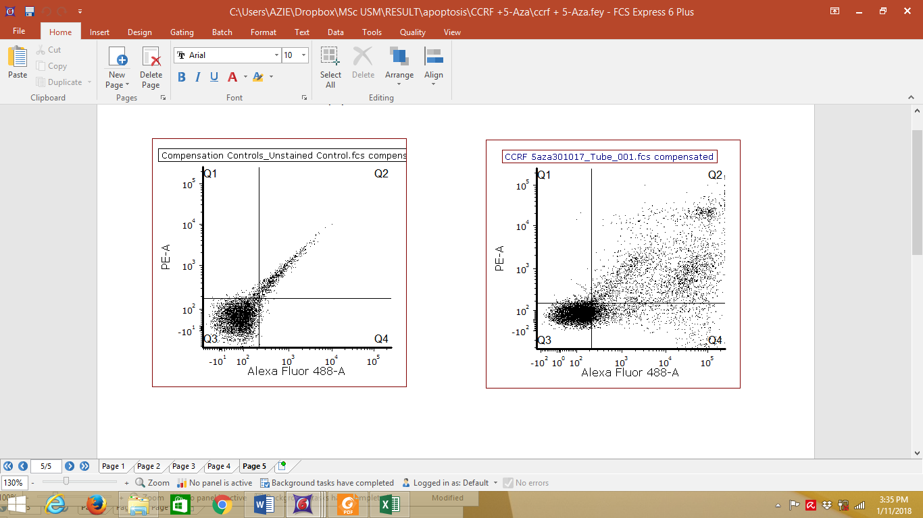
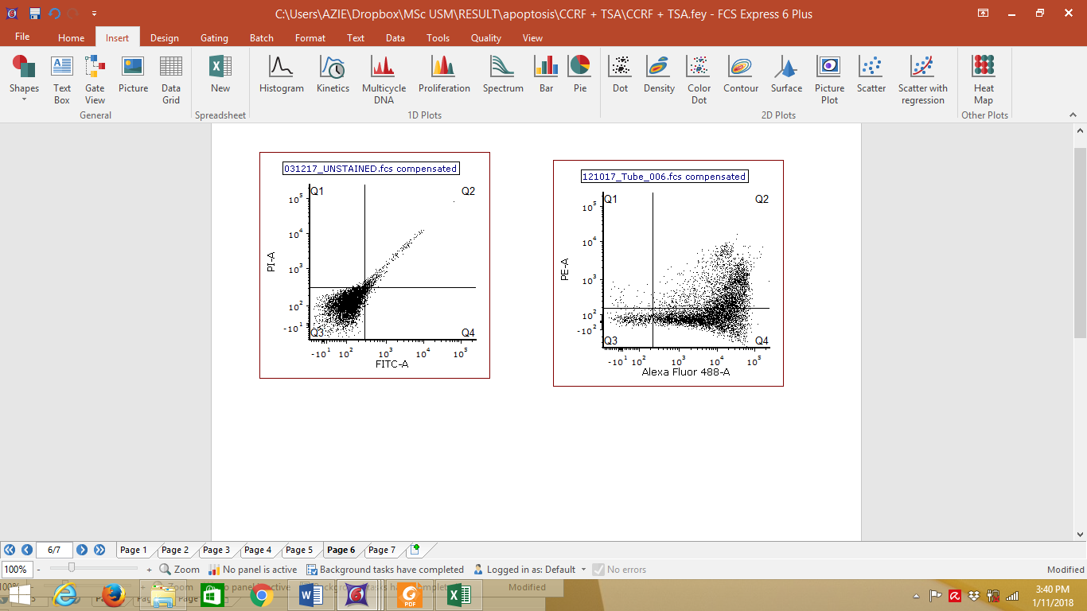
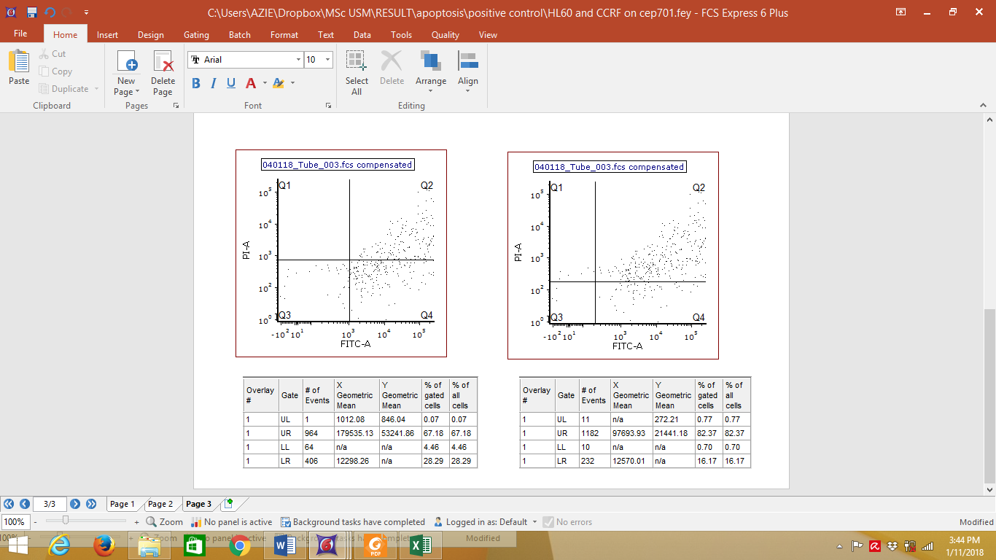
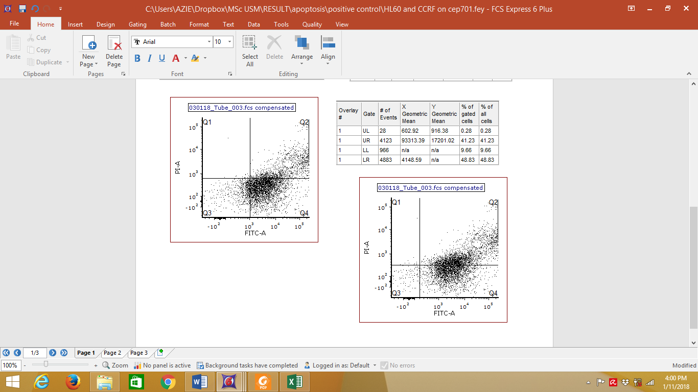
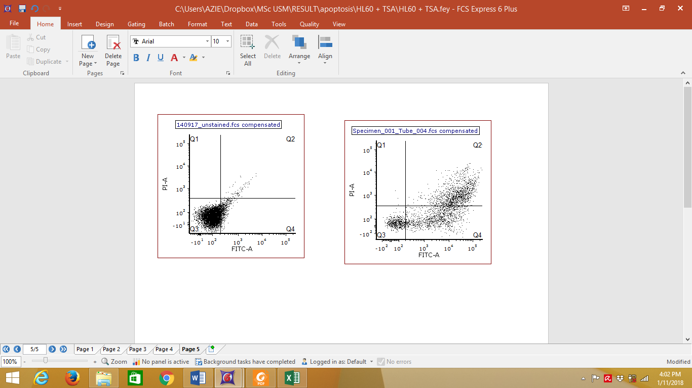
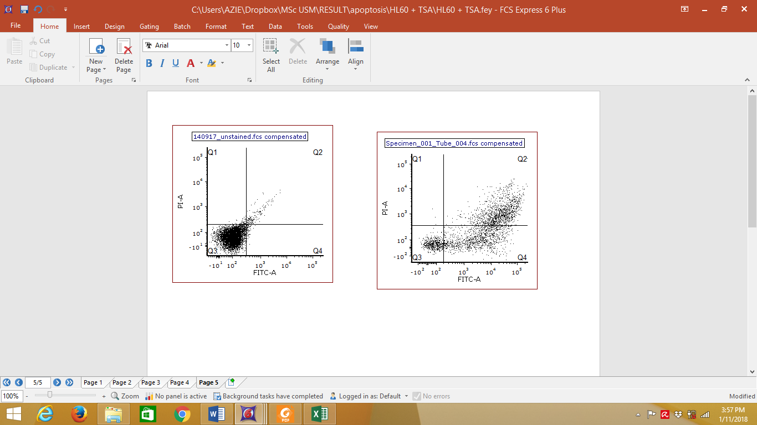
(i) Negative control, CCRF-CEM
(iii) 5-Aza; 2.01±0.1 µM, CCRF-CEM
(iv) TSA; 2.65±0.3 µM,
CCRF-CEM
(ii) Positive control, 0.85 ±0.1 µM Cep-701;
CCRF-CEM
(i) Negative control,
HL-60
(ii) Positive control, 0.42 ±0.2 µM Cep-701;
HL-60
(iii) 5-Aza; 1.98±0.2 µM, HL-60
(iv) TSA; 2.35±0.2 µM,
HL-60
(B)
(A)

